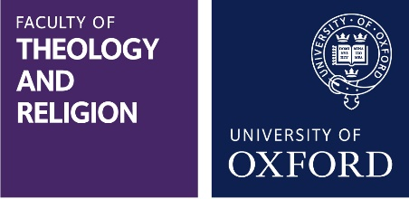

Unfading Light
Creativity and Prayer in 20th-century Russian Orthodoxy
7-8 March 2019, Wolfson College, University of Oxford

The conference aims to explore the divergent progressions of thought from late 19th century Russian ‘traditionalism’ towards a (re)discovery of the universal dimension of the Christianity of the Fathers in the 20th century; from the narrow constraints of the Russian Academy to an openness towards some more fertile currents of Western thought; from a Russian ‘fin de siècle’ fascination with non-Christian oriental mysticism to Eastern Orthodox hypostatic prayer within an ascesis of deified personhood.

Papers should bring together theological analyses of the interrelation and mutual dependence of these trains of thought within Russian Orthodoxy. This includes but is not limited to the role of sophiology in creating an interface between modernity, traditional approaches to iconography, Biblical exegesis and interpretations of the Fathers. The interrelated theological legacies of Fr. Sergius Bulgakov, Fr. George Florovsky, Mother Maria Skobtsova, Fr. Sophrony Sakharov, and Fr. Alexander Men will be subject to critical appraisal.

In this context, the following questions may be suggested for theological reflection:

* What does it mean to be a Christian person?
* How does Christian doctrine relate to experience?
* How does Christian asceticism relate to doctrine?
* How does human creativity correspond to the divine?
* Does beauty reveal Christ?

Among the confirmed speakers are Dr Rowan Williams, Metropolitan Kallistos Ware, Prof Andrew Louth, Prof Alexander Lingas, Sr Teresa Obolevitch, Dr Christoph Schneider, Dr Regula Zwahlen. The conference will include a concert and exhibition that seek to illustrate the principal theological themes.
Please note that the full attendance fee for a 2-day conference is £85 (£70 with student discount). Bursaries may be available for some speakers. Bookings can be made now on the online shop, which can be found here: https://www.oxforduniversitystores.co.uk/conferences-and-events/faculty-of-theology-and-religion/events/conference-unfading-light-creativity-and-prayer-in-20th-century-russian-orthodoxy

We welcome proposals of no more than 300 words. Researchers of all stages as well as postgraduates are encouraged to apply.

All conference correspondence, abstracts and enquiries should be addressed to the organising committee at the following email address: ROC@theology.ox.ac.uk

Deadline for proposals is 2nd January 2019. Decisions will be announced in later that month.

